**PROJECT TITLE**

**Student Name:** Amardeep **UID:23BCA10755**

**Branch:** BCA **Section/Group:**4 - A

**Semester:** 3rd **Date of Performance:** 25 OCT 2024

**Subject Name:** Desktop Publishing **Subject Code:**23CAP-204

1. **Aim/Overview of the project:** This project is about creating 5 pages of magzine to using Adobe Photoshop. The main goal was to design an eye-catching and informative magazine pages that would effectively attract the attention of the target audience. Adobe Photoshop was chosen for this project because it offers a wide range of tools and features that allow for professional design and customization. The was designed to include all the important details, while ensuring the design remains visually appealing. The project also aimed to help me learn how to use Photoshop’s tools like the text tool, shape tool, and layer styles to create a balanced and attractive layout. Through this project, I gained hands-on experience with Photoshop, making it a valuable learning experience for graphic design.
2. **Task to be done:**

**To Utilize Adobe Photoshop Tools:** Learn and apply various Adobe Photoshop tools and features, such as the text tool, shape tool, and layer styles, to enhance the design quality

**To Establish Information Hierarchy:** Organize the event information in a clear hierarchy, ensuring that the most important details, like the event title, are prominently displayed.

**To Experiment with Color and Typography:** Explore different color schemes and font styles to find the best combinations that enhance the overall design while maintaining readability.

**To Develop Technical Skills:** Improve technical skills in graphic design by completing the poster project from concept to final export, gaining practical experience in creating digital artwork

1. **Steps followed in making the project:** **Start to create magazine cover**

**1st Page**

1. Open the saved image and adjust the size.
2. Select the rectangle tool and adjust its width and height to 1000px and 2000px respectively.
3. Take the rectangle shape to the right side of the page and then select horizontal text tool.
4. Type “ Work Hard Dream Big.
5. Then go on windows and select character and fix it to 120px.
6. Adjust it to rectangle shape.
7. Go to blending option by clicking on layers, select advanced blending option fix fill opacity to 0% and knockout to shallow.
8. Merge layer 1 and 2.
9. Again select rectangle shape, width and height 1800px each.
10. Go to blending options,then fix the fill opacity to 0% and select stroke also with size 15px.
11. Select eclipse tool with color light pink.
12. At last to enhance it just add one more text cover tutorial.

**2nd Page**

1. Open the custom page in adobe photoshop.
2. Then open the saved image from files.
3. Press ctrl+a+c then ctrl+v.
4. Adjust it to full page.
5. Then click on select, then subject, then after that click on auto select.
6. A new layer, layer 2 will be there.
7. Then click on layer 2, click on move tool.
8. Change its pixels of rotation to -90.00.
9. Then click on text, go to layer 1.
10. Add text “vogue”. Select the text and change its size to 160pt.
11. Thenfix the cutout about the text.
12. Go to layer 2, select create clipping mask.
13. Then you can adjust according to your will.
14. Now wecan some more text around the image.
15. Create a rectangle box of white color.
16. Then again create small vertical rectangle shapes which will give a look of barcode.

**3rd Page**

1. Open custom page in adobe photoshop.
2. Open the saved image from files.
3. Select the rectangular marque tool from the toolbox, or use the shortcut M, and select half side of the canvas and create a mask.
4. Now select the text tool, or use the shortcut T,and drop down the text.
5. Hold the alt and drag the object to make a copy of the object.
6. Select all the text and make a group of all the text, then press ctrl+j and make a copy of model and bring it to forward.
7. Select all the layers and make group of all the layers, then add a solid color for adjustment to retro effect.
8. Now hold the the alt and click between the solid color and group, to make clipping mask and set the blending mode.
9. Now delete the layer mask of upper layer of model.
10. Select the text layer and convert it into shape and select the bottom nodes of the shape and extend it.
11. Now import or just drag the noisy background and set the the blending mode to create a retro effect.
12. Select the text tool, create a text box and drop down your body text.
13. Add your social media icons, here I am using fontello regular font for social media icons.

**4th Page**

1. Create a new file. Set up canvas as Width : 22 cm, Height : 29 cm, Resolution : 300, Color Mode : RGB. (general magazine size)

2. Paste the girl picture, when finished retouching, on background and hold shift to resize and make it fit to the art board. Go to File > Place Embedded.. And locate your picture file. Relabel to picture.

3. Insert the other text like shown on the pictures (create new text line by press return between typing):

1. 15 : Oswald Bold, 112 pt

2. PRO TIPS FOR : Oswald Regular, 18 pt

3. ADJUSTMENTS : Oswald Bold, 16.5 pt

4. INCREDIBLE COMPOSITES : Oswald Regular, 24 pt

5. Everything you need to know, from choosing photos to final colour grading : Oswald Light, 10 pt

6. CARL HEATON’S EXPERT GUIDE TO : Oswald Light, 29 pt

7. NATURAL RETOUCHING : Oswald Bold, 81 pt

4. I want to create a shape that attracts the eyes immediately, so I create a circle by using the Ellipse Tool, hold shift button and drag the mouse. I changed the colour by double click at the layer and use Eyedropper Tool to select the colour from the skin in midtone area and put it in shadow area to give it a better contrast. Then type

5. Separate the line by pressing the return button and rotate it a little bit to make it look more interesting (Press Cmd/Ctrl + T). Again, change the font colour by using Eyedropper Tool to select the colour from the shadow area to achieve a better contrast with the circle background.

6. Last but not least we want to make the text easier to read and have a focus point on the girl. I will make the top and bottom of the picture darker by transparent and gradient, so I click at picture layer use Rectangle Tool and drag around it around the whole artboard. At Properties Tab, choose Gradient, foreground to transparent, change foreground to black, move the opacity stop slider from the right side to reveal her face (darker only forehead and hair), Linear 90. Then change layer opacity around 70%

7. 10. Create another Rectangle do the same thing as in Step 9., but change the values of Linear: -90 and opacity to around 30%

5th Page

You should now have two document windows open in Photoshop.

The quickest method for moving an image between documents is to drag and drop the layer. Select the Move Tool by using the shortcut “v” on your keyboard, click on the image and drag it up to the tab of the other document. Wait until you see Photoshop switch windows and then drop your image into the blank A4 canvas.

You can also use the Duplicate Layer function. Right click on the layer in the Layers Panel and select Duplicate Layer to open Photoshop’s Duplicate Layer dialog box. In the Destination section, choose “front cover assignment”. This option is useful when you have lots of tabs open.

After we inserted the image, we pressed Ctrl+T to start the transform function – you should see the transform border appear around the layer. Scale the layer down to 75% of the original size. Commit the transform by clicking the tick icon at the top of the screen or by pressing Enter.

We then used the Move Tool to reposition the layer and achieve the following look:

The title is probably the most important element of the magazine’s branding because the font choice and overall style encode information about the tone and values of the publication. Take your time and stick to our instructions to create this fantastic looking title:

First, select the Horizontal Type Tool on the Toolbar or by pressing “t” on your keyboard. We used the Options bar at the top of the screen to select the Arial Black font and change the size to 130pt. We opened the Color Picker dialog box and changed the hexadecimal value to #21458f so the colour of the title coordinates effectively with the main image. Just copy these numbers into the field at the bottom of the box. Press and hold the left mouse button while you drag the cursor to create a large text layer. Type “Limited” and confirm the changes by clicking the tick icon at the top of the screen.

If the Character panel is not available, click Window > Character in the main menu. With the all the text highlighted, we changed the tracking to -50.

Create a new Text layer. Change the size of font to 18pt and select white – #ffffff. We also had to change the tracking from the previous -50 setting to zero in the Character tab.

Type in the word “EDITION”. We went for capital letters again to signify confidence.

Make sure this new text layer is above the rectangle layer in the Layers panel, so the letters are not hidden by the grey background on the canvas.

Finally, we want the model’s head to be positioned in front of the text. This bit can be tricky and there are plenty of different ways to achieve the effect.

You could select the “LIMITED” layer, then click the “Add Layer Mask” icon at the bottom of the Layers panel. Layer masking is an effective way to hide parts of image without actually erasing them.

Use the Pencil tool to delete the parts of the letters which should be behind the model’s head.

Mistakes are inevitable but you can undo them in the History panel.

However, we are going to take advantage of the Remove background action to achieve a more precise and professional finish. Duplicate the main image and move the copy above “LIMITED”. Then simply use the AI tool to remove the background.

4. Result/Output/Writing Summary: In conclusion, the project of creating magazine pages using Adobe Photoshop has been a valuable learning experience that allowed me to enhance my design skills and gain practical knowledge of graphic design principles.

Throughout the process, I encountered various challenges, such as navigating software tools, achieving a balanced layout, and selecting appropriate colors, which pushed me to develop problem-solving skills and seek resources for improvement. The feedback received during the project provided insight into how my design was perceived by others, and it highlighted the importance of collaboration in the creative process. Moving forward, I plan to implement structured feedback processes and further develop my technical skills in Photoshop to produce even more effective designs. Overall, this project has deepened my understanding of design and has motivated me to continue exploring the creative possibilities within graphic design. The skills and knowledge gained will undoubtedly contribute to my growth as a designer, enabling me to tackle future projects with increased confidence and creativity.

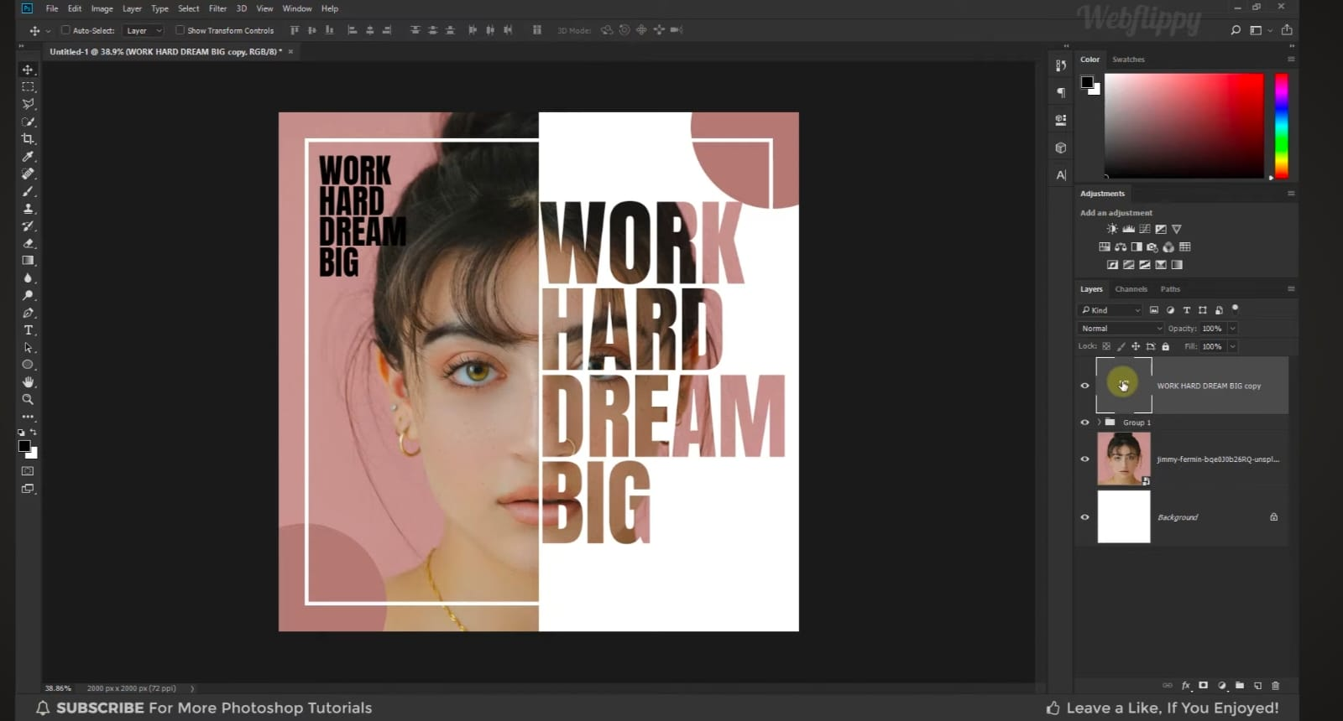

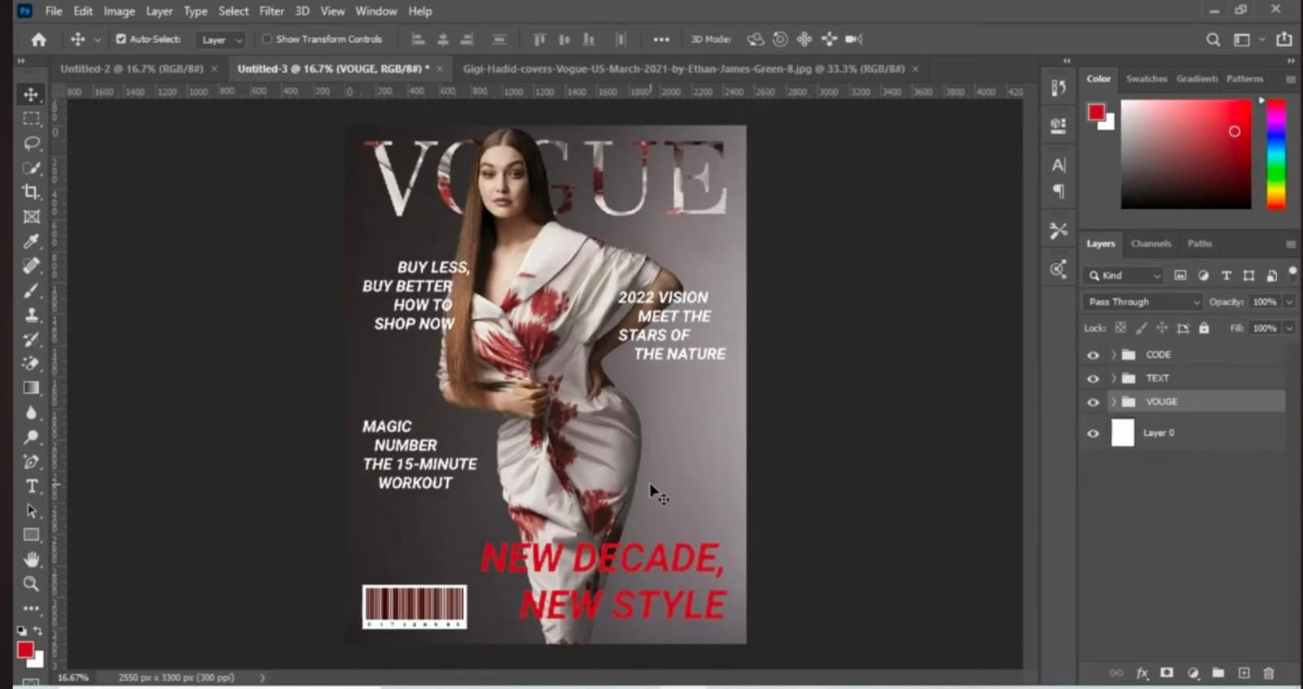

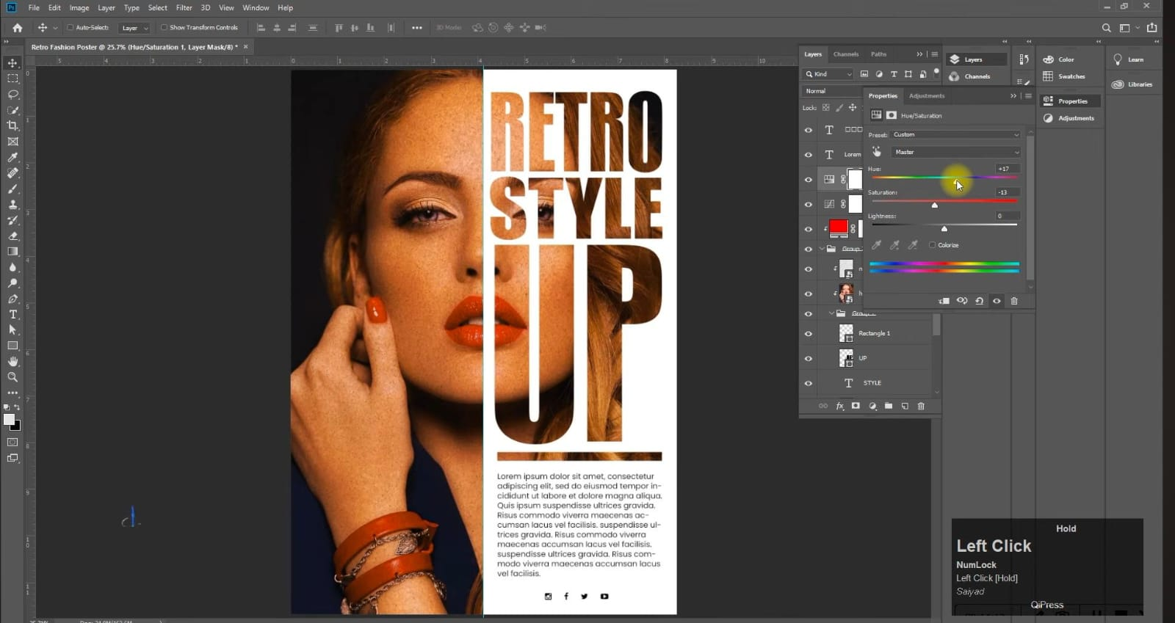

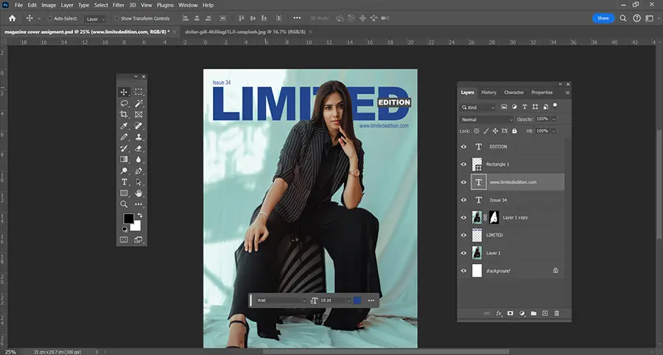

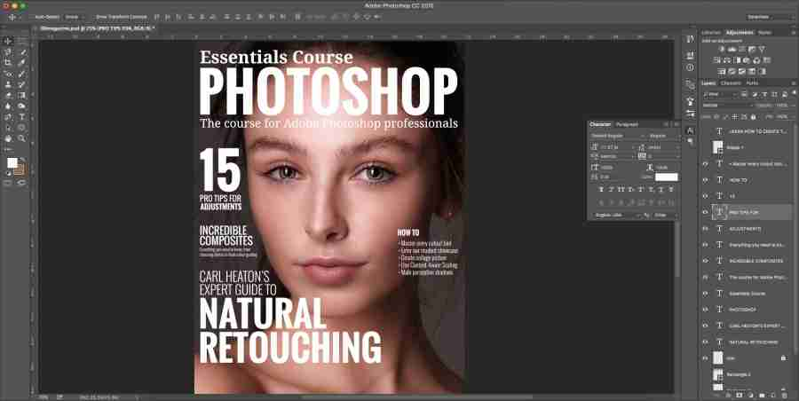

**5. Learning outcomes (What I have learnt):**

**1. Various tools such as lasso tool, marque tool etc.**

**2. How to improve the imperfections in an image.**

**3. Learned about layer management.**

**4. How to change the background of nay image.**

**5.How to copy and paste image by shortcut.**

|  |  |  |  |
| --- | --- | --- | --- |
| Sr. No. | Parameters | Marks Obtained | Maximum Marks |
| 1. | Demonstration and Performance (Pre Lab Quiz) |  | 5 |
| 2. | Worksheet |  | 10 |
| 3. | Post Lab Quiz |  | 5 |

**Evaluation Grid:**